Desarrollo de Aplicaciones Multiplataforma

Actividad 01

Desarrollo de Aplicaciones Android (I)

Programación multimedia y dispositivos móviles

Actividad

Desarrollo de Aplicaciones Android (I)

**Objetivos**

Desarrollar Aplicaciones para teléfono móvil.

Usar controles básicos.

Diseñar layouts.

|  |
| --- |
|  |
|  |

|  |  |
| --- | --- |
| **Antes de empezar…** | |
| Nombre | Cristina |
| Apellidos | Pérez Becerro |
| Módulo/Crédito | M08 Programación multimedia y dispositivos móviles |
| UF (solo ciclos LOE) | 1 |
| Título de la actividad | Desarrollo de aplicaciones Android |

C**onversor de divisas**

Desarrollar una aplicación Android que permita la conversión entre divisas. La aplicación debe permitir al usuario convertir euros a una divisa extranjera (ofrecer al menos 10 divisas a elegir) y viceversa. Indicaciones:

* Las tasas de cambio de cada divisa deberán guardarse en una estructura de datos; serán fijas y no podrán cambiarse.
* A la hora de presentar el listado de monedas extranjeras al usuario, debe utilizarse una lista desplegable o cualquier otro sistema que permita la facilidad de uso.

La App debe ser lo más intuitiva y fácil de usar posible y debe evitar cualquier comportamiento inestable por información errónea o no proporcionada.

En primer lugar, comenzamos diseñando el **layout**,la parte XML, donde declaramos todos los elementos y sus propiedades:

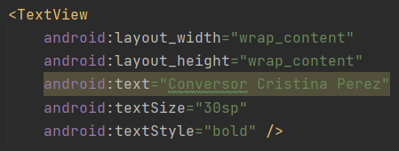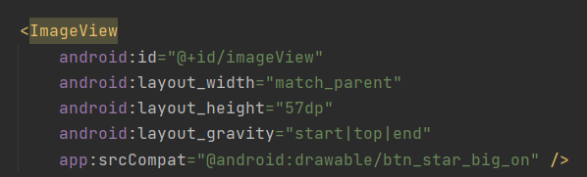Imagen con localizacion y tamaño Texto que muestra el titulo de la aplicación

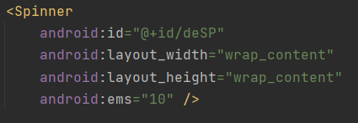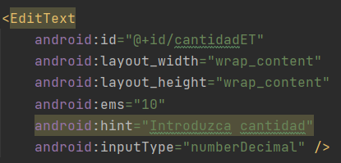Cuadro de texto editable para introducir el valor Desplegables para elegir las monedas

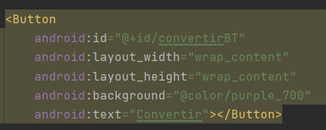Boton para aceptar la conversión

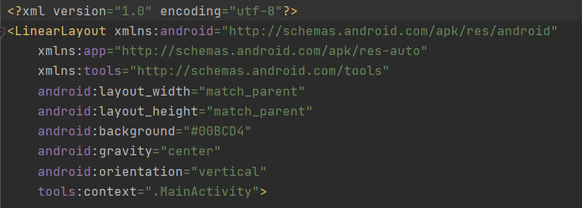Todo el layout tiene una estructura linear para mas comodidad de cara a estructurar elementos

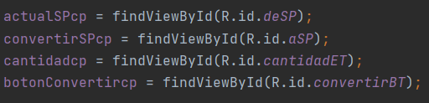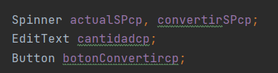En la parte de java, primero declaramos las variables de los elementos, y los relacionamos con la parte xml

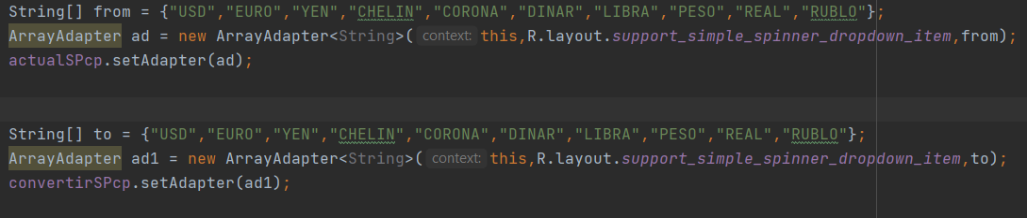Declaramos 2 ArrayAdapter para rellenar los spinners con las monedas a elegir

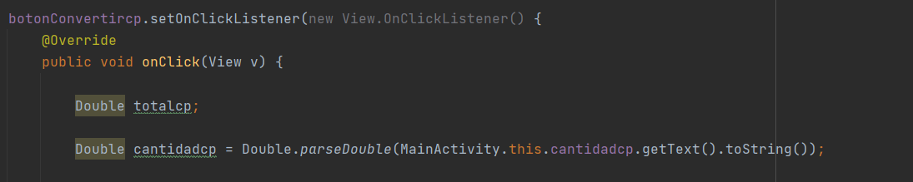Programamos un evento para el boton y declaramos variables a utilizar en el metodo de conversion

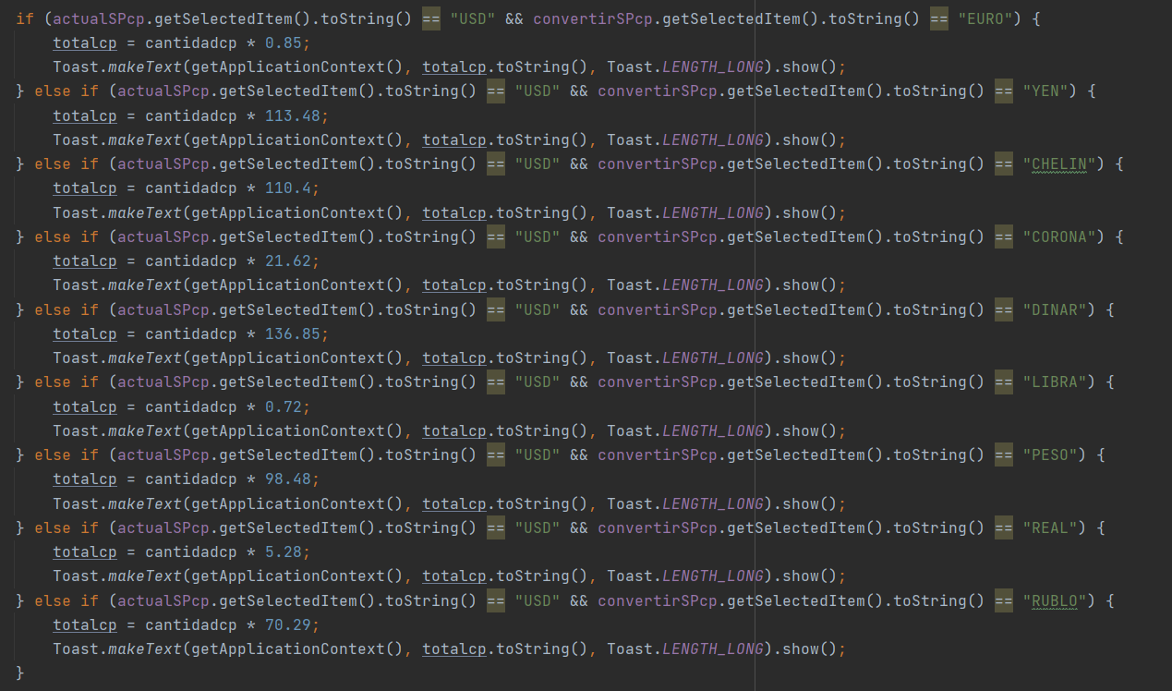Método de conversion (Seguramente haya otro metodo más práctico o más corto, pero a mi no me han funcionado). He utilizado esta misma parte del codigo para cada moneda.

**Control de excepciones**

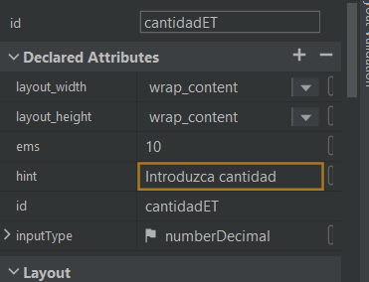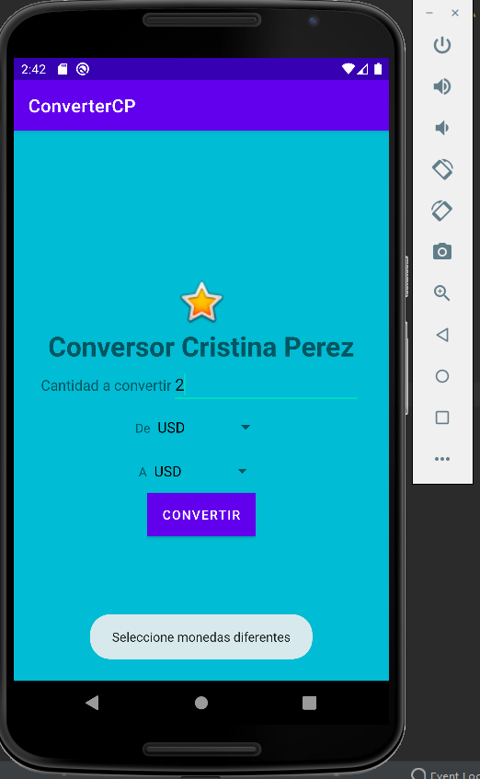

Para el control de excepciones he configurado el editText solo con entrada **numberDecimal**, y utilizado un if que muestre "Seleccione monedas diferentes” con un **Toast** en el caso de que las dos monedas elegidas sean la misma. Para mas comodidad he configurado el valor **hint** con un texto que desaparece al escribir.

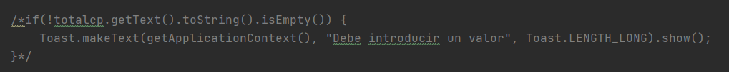Tambien he querido controlar la excepcion en el caso de que no se introduzca un valor pero no he sido capaz de entender el porqué del error en el setText() y en isEmpty().

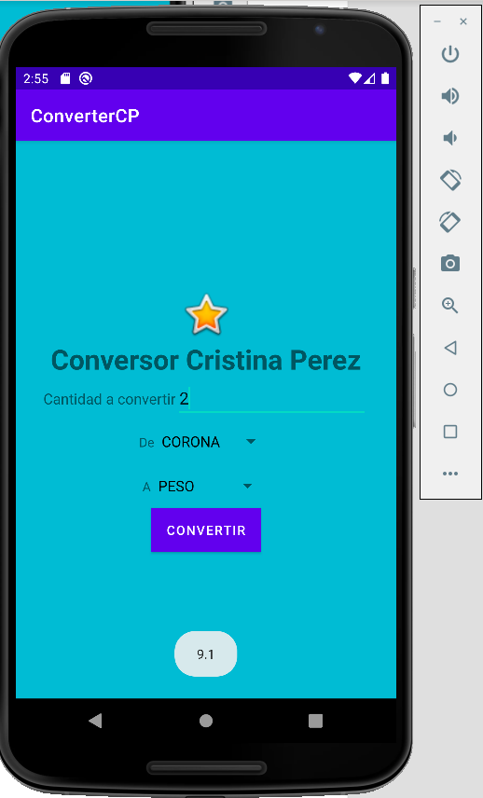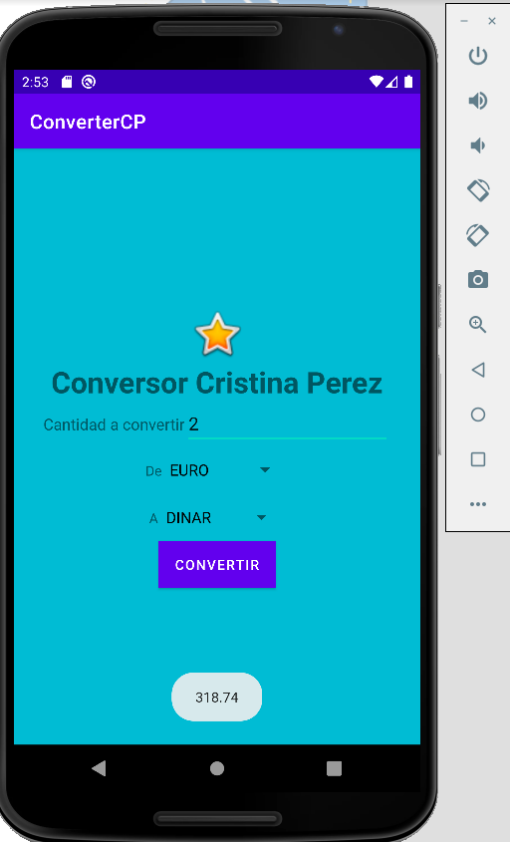Conversor en funcionamiento

activity_main.XML completo (Texto)

<?xml version="1.0" encoding="utf-8"?>  
<LinearLayout xmlns:android="http://schemas.android.com/apk/res/android"  
 xmlns:app="http://schemas.android.com/apk/res-auto"  
 xmlns:tools="http://schemas.android.com/tools"  
 android:layout_width="match_parent"  
 android:layout_height="match_parent"  
 android:background="#00BCD4"  
 android:gravity="center"  
 android:orientation="vertical"  
 tools:context=".MainActivity">  
  
 <ImageView  
 android:id="@+id/imageView"  
 android:layout_width="match_parent"  
 android:layout_height="57dp"  
 android:layout_gravity="start|top|end"  
 app:srcCompat="@android:drawable/btn_star_big_on" />  
  
 <LinearLayout  
 android:layout_width="wrap_content"  
 android:layout_height="wrap_content"  
 android:orientation="horizontal">  
  
  
 <TextView  
 android:layout_width="wrap_content"  
 android:layout_height="wrap_content"  
 android:text="Conversor Cristina Perez"  
 android:textSize="30sp"  
 android:textStyle="bold" />  
   
 </LinearLayout>  
  
 <LinearLayout  
 android:layout_width="wrap_content"  
 android:layout_height="wrap_content"  
 android:orientation="horizontal">  
  
  
 <TextView  
 android:layout_width="wrap_content"  
 android:layout_height="wrap_content"  
 android:text="Cantidad a convertir"  
 android:textSize="16sp" />  
  
 <EditText  
 android:id="@+id/cantidadET"  
 android:layout_width="wrap_content"  
 android:layout_height="wrap_content"  
 android:ems="10"  
 android:hint="Introduzca cantidad"  
 android:inputType="numberDecimal" />  
  
 </LinearLayout>  
  
 <LinearLayout  
 android:layout_width="wrap_content"  
 android:layout_height="wrap_content"  
 android:orientation="horizontal">  
  
  
 <TextView  
 android:layout_width="wrap_content"  
 android:layout_height="wrap_content"  
 android:text="De" />  
  
 <Spinner  
 android:id="@+id/deSP"  
 android:layout_width="wrap_content"  
 android:layout_height="wrap_content"  
 android:ems="10" />  
  
 </LinearLayout>  
  
 <LinearLayout  
 android:layout_width="wrap_content"  
 android:layout_height="wrap_content"  
 android:orientation="horizontal">  
  
  
 <TextView  
 android:layout_width="wrap_content"  
 android:layout_height="wrap_content"  
 android:text="A" />  
  
 <Spinner  
 android:id="@+id/aSP"  
 android:layout_width="wrap_content"  
 android:layout_height="wrap_content"  
 android:ems="10" />  
   
 </LinearLayout>  
  
 <LinearLayout  
 android:layout_width="wrap_content"  
 android:layout_height="wrap_content"  
 android:orientation="horizontal">  
  
  
 </LinearLayout>  
  
 <Button  
 android:id="@+id/convertirBT"  
 android:layout_width="wrap_content"  
 android:layout_height="wrap_content"  
 android:background="@color/purple_700"  
 android:text="Convertir"></Button>  
   
</LinearLayout>

MainActivity.java completo (Texto)

package com.example.convertercp;  
  
import android.os.Bundle;  
import android.view.View;  
import android.widget.ArrayAdapter;  
import android.widget.Button;  
import android.widget.EditText;  
import android.widget.Spinner;  
import android.widget.Toast;  
  
import androidx.appcompat.app.AppCompatActivity;  
  
public class MainActivity extends AppCompatActivity {  
  
  
 Spinner actualSPcp, convertirSPcp;  
 EditText cantidadcp;  
 Button botonConvertircp;  
  
 @Override  
 protected void onCreate(Bundle savedInstanceState) {  
 super.onCreate(savedInstanceState);  
 setContentView(R.layout.*activity_main*);  
  
 actualSPcp = findViewById(R.id.*deSP*);  
 convertirSPcp = findViewById(R.id.*aSP*);  
 cantidadcp = findViewById(R.id.*cantidadET*);  
 botonConvertircp = findViewById(R.id.*convertirBT*);  
  
 String[] from = {"USD","EURO","YEN","CHELIN","CORONA","DINAR","LIBRA","PESO","REAL","RUBLO"};  
 ArrayAdapter ad = new ArrayAdapter<String>(this,R.layout.*support_simple_spinner_dropdown_item*,from);  
 actualSPcp.setAdapter(ad);  
  
  
 String[] to = {"USD","EURO","YEN","CHELIN","CORONA","DINAR","LIBRA","PESO","REAL","RUBLO"};  
 ArrayAdapter ad1 = new ArrayAdapter<String>(this,R.layout.*support_simple_spinner_dropdown_item*,to);  
 convertirSPcp.setAdapter(ad1);  
  
  
  
 botonConvertircp.setOnClickListener(new View.OnClickListener() {  
 @Override  
 public void onClick(View v) {  
  
 Double totalcp;  
  
 Double cantidadcp = Double.*parseDouble*(MainActivity.this.cantidadcp.getText().toString());  
  
  
 /*if(!totalcp.getText().toString().isEmpty()) {  
 Toast.makeText(getApplicationContext(), "Debe introducir un valor", Toast.LENGTH_LONG).show();  
 }*/  
  
  
 if (actualSPcp != convertirSPcp) {  
  
 if (actualSPcp.getSelectedItem().toString() == "USD" && convertirSPcp.getSelectedItem().toString() == "EURO") {  
 totalcp = cantidadcp * 0.85;  
 Toast.*makeText*(getApplicationContext(), totalcp.toString(), Toast.*LENGTH_LONG*).show();  
 } else if (actualSPcp.getSelectedItem().toString() == "USD" && convertirSPcp.getSelectedItem().toString() == "YEN") {  
 totalcp = cantidadcp * 113.48;  
 Toast.*makeText*(getApplicationContext(), totalcp.toString(), Toast.*LENGTH_LONG*).show();  
 } else if (actualSPcp.getSelectedItem().toString() == "USD" && convertirSPcp.getSelectedItem().toString() == "CHELIN") {  
 totalcp = cantidadcp * 110.4;  
 Toast.*makeText*(getApplicationContext(), totalcp.toString(), Toast.*LENGTH_LONG*).show();  
 } else if (actualSPcp.getSelectedItem().toString() == "USD" && convertirSPcp.getSelectedItem().toString() == "CORONA") {  
 totalcp = cantidadcp * 21.62;  
 Toast.*makeText*(getApplicationContext(), totalcp.toString(), Toast.*LENGTH_LONG*).show();  
 } else if (actualSPcp.getSelectedItem().toString() == "USD" && convertirSPcp.getSelectedItem().toString() == "DINAR") {  
 totalcp = cantidadcp * 136.85;  
 Toast.*makeText*(getApplicationContext(), totalcp.toString(), Toast.*LENGTH_LONG*).show();  
 } else if (actualSPcp.getSelectedItem().toString() == "USD" && convertirSPcp.getSelectedItem().toString() == "LIBRA") {  
 totalcp = cantidadcp * 0.72;  
 Toast.*makeText*(getApplicationContext(), totalcp.toString(), Toast.*LENGTH_LONG*).show();  
 } else if (actualSPcp.getSelectedItem().toString() == "USD" && convertirSPcp.getSelectedItem().toString() == "PESO") {  
 totalcp = cantidadcp * 98.48;  
 Toast.*makeText*(getApplicationContext(), totalcp.toString(), Toast.*LENGTH_LONG*).show();  
 } else if (actualSPcp.getSelectedItem().toString() == "USD" && convertirSPcp.getSelectedItem().toString() == "REAL") {  
 totalcp = cantidadcp * 5.28;  
 Toast.*makeText*(getApplicationContext(), totalcp.toString(), Toast.*LENGTH_LONG*).show();  
 } else if (actualSPcp.getSelectedItem().toString() == "USD" && convertirSPcp.getSelectedItem().toString() == "RUBLO") {  
 totalcp = cantidadcp * 70.29;  
 Toast.*makeText*(getApplicationContext(), totalcp.toString(), Toast.*LENGTH_LONG*).show();  
 }  
  
  
 if (actualSPcp.getSelectedItem().toString() == "EURO" && convertirSPcp.getSelectedItem().toString() == "USD") {  
 totalcp = cantidadcp * 1.16;  
 Toast.*makeText*(getApplicationContext(), totalcp.toString(), Toast.*LENGTH_LONG*).show();  
 } else if (actualSPcp.getSelectedItem().toString() == "EURO" && convertirSPcp.getSelectedItem().toString() == "YEN") {  
 totalcp = cantidadcp * 132.15;  
 Toast.*makeText*(getApplicationContext(), totalcp.toString(), Toast.*LENGTH_LONG*).show();  
 } else if (actualSPcp.getSelectedItem().toString() == "EURO" && convertirSPcp.getSelectedItem().toString() == "CHELIN") {  
 totalcp = cantidadcp * 129.36;  
 Toast.*makeText*(getApplicationContext(), totalcp.toString(), Toast.*LENGTH_LONG*).show();  
 } else if (actualSPcp.getSelectedItem().toString() == "EURO" && convertirSPcp.getSelectedItem().toString() == "CORONA") {  
 totalcp = cantidadcp * 25.33;  
 Toast.*makeText*(getApplicationContext(), totalcp.toString(), Toast.*LENGTH_LONG*).show();  
 } else if (actualSPcp.getSelectedItem().toString() == "EURO" && convertirSPcp.getSelectedItem().toString() == "DINAR") {  
 totalcp = cantidadcp * 159.37;  
 Toast.*makeText*(getApplicationContext(), totalcp.toString(), Toast.*LENGTH_LONG*).show();  
 } else if (actualSPcp.getSelectedItem().toString() == "EURO" && convertirSPcp.getSelectedItem().toString() == "LIBRA") {  
 totalcp = cantidadcp * 0.84;  
 Toast.*makeText*(getApplicationContext(), totalcp.toString(), Toast.*LENGTH_LONG*).show();  
 } else if (actualSPcp.getSelectedItem().toString() == "EURO" && convertirSPcp.getSelectedItem().toString() == "PESO") {  
 totalcp = cantidadcp * 114.68;  
 Toast.*makeText*(getApplicationContext(), totalcp.toString(), Toast.*LENGTH_LONG*).show();  
 } else if (actualSPcp.getSelectedItem().toString() == "EURO" && convertirSPcp.getSelectedItem().toString() == "REAL") {  
 totalcp = cantidadcp * 6.15;  
 Toast.*makeText*(getApplicationContext(), totalcp.toString(), Toast.*LENGTH_LONG*).show();  
 } else if (actualSPcp.getSelectedItem().toString() == "EURO" && convertirSPcp.getSelectedItem().toString() == "RUBLO") {  
 totalcp = cantidadcp * 85.24;  
 Toast.*makeText*(getApplicationContext(), totalcp.toString(), Toast.*LENGTH_LONG*).show();  
 }  
  
  
 if (actualSPcp.getSelectedItem().toString() == "YEN" && convertirSPcp.getSelectedItem().toString() == "USD") {  
 totalcp = cantidadcp * 0.0091;  
 Toast.*makeText*(getApplicationContext(), totalcp.toString(), Toast.*LENGTH_LONG*).show();  
 } else if (actualSPcp.getSelectedItem().toString() == "YEN" && convertirSPcp.getSelectedItem().toString() == "EURO") {  
 totalcp = cantidadcp * 0.0078;  
 Toast.*makeText*(getApplicationContext(), totalcp.toString(), Toast.*LENGTH_LONG*).show();  
 } else if (actualSPcp.getSelectedItem().toString() == "YEN" && convertirSPcp.getSelectedItem().toString() == "CHELIN") {  
 totalcp = cantidadcp * 1.004;  
 Toast.*makeText*(getApplicationContext(), totalcp.toString(), Toast.*LENGTH_LONG*).show();  
 } else if (actualSPcp.getSelectedItem().toString() == "YEN" && convertirSPcp.getSelectedItem().toString() == "CORONA") {  
 totalcp = cantidadcp * 0.19;  
 Toast.*makeText*(getApplicationContext(), totalcp.toString(), Toast.*LENGTH_LONG*).show();  
 } else if (actualSPcp.getSelectedItem().toString() == "YEN" && convertirSPcp.getSelectedItem().toString() == "DINAR") {  
 totalcp = cantidadcp * 1.24;  
 Toast.*makeText*(getApplicationContext(), totalcp.toString(), Toast.*LENGTH_LONG*).show();  
 } else if (actualSPcp.getSelectedItem().toString() == "YEN" && convertirSPcp.getSelectedItem().toString() == "LIBRA") {  
 totalcp = cantidadcp * 0.0067;  
 Toast.*makeText*(getApplicationContext(), totalcp.toString(), Toast.*LENGTH_LONG*).show();  
 } else if (actualSPcp.getSelectedItem().toString() == "YEN" && convertirSPcp.getSelectedItem().toString() == "PESO") {  
 totalcp = cantidadcp * 7.16;  
 Toast.*makeText*(getApplicationContext(), totalcp.toString(), Toast.*LENGTH_LONG*).show();  
 } else if (actualSPcp.getSelectedItem().toString() == "YEN" && convertirSPcp.getSelectedItem().toString() == "REAL") {  
 totalcp = cantidadcp * 0.04;  
 Toast.*makeText*(getApplicationContext(), totalcp.toString(), Toast.*LENGTH_LONG*).show();  
 } else if (actualSPcp.getSelectedItem().toString() == "YEN" && convertirSPcp.getSelectedItem().toString() == "RUBLO") {  
 totalcp = cantidadcp * 0.66;  
 Toast.*makeText*(getApplicationContext(), totalcp.toString(), Toast.*LENGTH_LONG*).show();  
 }  
  
  
 if (actualSPcp.getSelectedItem().toString() == "CHELIN" && convertirSPcp.getSelectedItem().toString() == "USD") {  
 totalcp = cantidadcp * 0.0091;  
 Toast.*makeText*(getApplicationContext(), totalcp.toString(), Toast.*LENGTH_LONG*).show();  
 } else if (actualSPcp.getSelectedItem().toString() == "CHELIN" && convertirSPcp.getSelectedItem().toString() == "EURO") {  
 totalcp = cantidadcp * 0.007;  
 Toast.*makeText*(getApplicationContext(), totalcp.toString(), Toast.*LENGTH_LONG*).show();  
 } else if (actualSPcp.getSelectedItem().toString() == "CHELIN" && convertirSPcp.getSelectedItem().toString() == "YEN") {  
 totalcp = cantidadcp * 0.99;  
 Toast.*makeText*(getApplicationContext(), totalcp.toString(), Toast.*LENGTH_LONG*).show();  
 } else if (actualSPcp.getSelectedItem().toString() == "CHELIN" && convertirSPcp.getSelectedItem().toString() == "CORONA") {  
 totalcp = cantidadcp * 0.19;  
 Toast.*makeText*(getApplicationContext(), totalcp.toString(), Toast.*LENGTH_LONG*).show();  
 } else if (actualSPcp.getSelectedItem().toString() == "CHELIN" && convertirSPcp.getSelectedItem().toString() == "DINAR") {  
 totalcp = cantidadcp * 1.23;  
 Toast.*makeText*(getApplicationContext(), totalcp.toString(), Toast.*LENGTH_LONG*).show();  
 } else if (actualSPcp.getSelectedItem().toString() == "CHELIN" && convertirSPcp.getSelectedItem().toString() == "LIBRA") {  
 totalcp = cantidadcp * 0.0066;  
 Toast.*makeText*(getApplicationContext(), totalcp.toString(), Toast.*LENGTH_LONG*).show();  
 } else if (actualSPcp.getSelectedItem().toString() == "CHELIN" && convertirSPcp.getSelectedItem().toString() == "PESO") {  
 totalcp = cantidadcp * 0.89;  
 Toast.*makeText*(getApplicationContext(), totalcp.toString(), Toast.*LENGTH_LONG*).show();  
 } else if (actualSPcp.getSelectedItem().toString() == "CHELIN" && convertirSPcp.getSelectedItem().toString() == "REAL") {  
 totalcp = cantidadcp * 0.04;  
 Toast.*makeText*(getApplicationContext(), totalcp.toString(), Toast.*LENGTH_LONG*).show();  
 } else if (actualSPcp.getSelectedItem().toString() == "CHELIN" && convertirSPcp.getSelectedItem().toString() == "RUBLO") {  
 totalcp = cantidadcp * 0.63;  
 Toast.*makeText*(getApplicationContext(), totalcp.toString(), Toast.*LENGTH_LONG*).show();  
 }  
  
  
 if (actualSPcp.getSelectedItem().toString() == "CORONA" && convertirSPcp.getSelectedItem().toString() == "USD") {  
 totalcp = cantidadcp * 0.046;  
 Toast.*makeText*(getApplicationContext(), totalcp.toString(), Toast.*LENGTH_LONG*).show();  
 } else if (actualSPcp.getSelectedItem().toString() == "CORONA" && convertirSPcp.getSelectedItem().toString() == "EURO") {  
 totalcp = cantidadcp * 0.039;  
 Toast.*makeText*(getApplicationContext(), totalcp.toString(), Toast.*LENGTH_LONG*).show();  
 } else if (actualSPcp.getSelectedItem().toString() == "CORONA" && convertirSPcp.getSelectedItem().toString() == "YEN") {  
 totalcp = cantidadcp * 5.08;  
 Toast.*makeText*(getApplicationContext(), totalcp.toString(), Toast.*LENGTH_LONG*).show();  
 } else if (actualSPcp.getSelectedItem().toString() == "CORONA" && convertirSPcp.getSelectedItem().toString() == "CHELIN") {  
 totalcp = cantidadcp * 5.10;  
 Toast.*makeText*(getApplicationContext(), totalcp.toString(), Toast.*LENGTH_LONG*).show();  
 } else if (actualSPcp.getSelectedItem().toString() == "CORONA" && convertirSPcp.getSelectedItem().toString() == "DINAR") {  
 totalcp = cantidadcp * 6.32;  
 Toast.*makeText*(getApplicationContext(), totalcp.toString(), Toast.*LENGTH_LONG*).show();  
 } else if (actualSPcp.getSelectedItem().toString() == "CORONA" && convertirSPcp.getSelectedItem().toString() == "LIBRA") {  
 totalcp = cantidadcp * 0.033;  
 Toast.*makeText*(getApplicationContext(), totalcp.toString(), Toast.*LENGTH_LONG*).show();  
 } else if (actualSPcp.getSelectedItem().toString() == "CORONA" && convertirSPcp.getSelectedItem().toString() == "PESO") {  
 totalcp = cantidadcp * 4.55;  
 Toast.*makeText*(getApplicationContext(), totalcp.toString(), Toast.*LENGTH_LONG*).show();  
 } else if (actualSPcp.getSelectedItem().toString() == "CORONA" && convertirSPcp.getSelectedItem().toString() == "REAL") {  
 totalcp = cantidadcp * 0.24;  
 Toast.*makeText*(getApplicationContext(), totalcp.toString(), Toast.*LENGTH_LONG*).show();  
 } else if (actualSPcp.getSelectedItem().toString() == "CORONA" && convertirSPcp.getSelectedItem().toString() == "RUBLO") {  
 totalcp = cantidadcp * 3.36;  
 Toast.*makeText*(getApplicationContext(), totalcp.toString(), Toast.*LENGTH_LONG*).show();  
 }  
  
  
 if (actualSPcp.getSelectedItem().toString() == "DINAR" && convertirSPcp.getSelectedItem().toString() == "USD") {  
 totalcp = cantidadcp * 0.007;  
 Toast.*makeText*(getApplicationContext(), totalcp.toString(), Toast.*LENGTH_LONG*).show();  
 } else if (actualSPcp.getSelectedItem().toString() == "DINAR" && convertirSPcp.getSelectedItem().toString() == "EURO") {  
 totalcp = cantidadcp * 0.006;  
 Toast.*makeText*(getApplicationContext(), totalcp.toString(), Toast.*LENGTH_LONG*).show();  
 } else if (actualSPcp.getSelectedItem().toString() == "DINAR" && convertirSPcp.getSelectedItem().toString() == "YEN") {  
 totalcp = cantidadcp * 0.80;  
 Toast.*makeText*(getApplicationContext(), totalcp.toString(), Toast.*LENGTH_LONG*).show();  
 } else if (actualSPcp.getSelectedItem().toString() == "DINAR" && convertirSPcp.getSelectedItem().toString() == "CHELIN") {  
 totalcp = cantidadcp * 0.80;  
 Toast.*makeText*(getApplicationContext(), totalcp.toString(), Toast.*LENGTH_LONG*).show();  
 } else if (actualSPcp.getSelectedItem().toString() == "DINAR" && convertirSPcp.getSelectedItem().toString() == "CORONA") {  
 totalcp = cantidadcp * 0.15;  
 Toast.*makeText*(getApplicationContext(), totalcp.toString(), Toast.*LENGTH_LONG*).show();  
 } else if (actualSPcp.getSelectedItem().toString() == "DINAR" && convertirSPcp.getSelectedItem().toString() == "LIBRA") {  
 totalcp = cantidadcp * 0.005;  
 Toast.*makeText*(getApplicationContext(), totalcp.toString(), Toast.*LENGTH_LONG*).show();  
 } else if (actualSPcp.getSelectedItem().toString() == "DINAR" && convertirSPcp.getSelectedItem().toString() == "PESO") {  
 totalcp = cantidadcp * 0.71;  
 Toast.*makeText*(getApplicationContext(), totalcp.toString(), Toast.*LENGTH_LONG*).show();  
 } else if (actualSPcp.getSelectedItem().toString() == "DINAR" && convertirSPcp.getSelectedItem().toString() == "REAL") {  
 totalcp = cantidadcp * 0.038;  
 Toast.*makeText*(getApplicationContext(), totalcp.toString(), Toast.*LENGTH_LONG*).show();  
 } else if (actualSPcp.getSelectedItem().toString() == "DINAR" && convertirSPcp.getSelectedItem().toString() == "RUBLO") {  
 totalcp = cantidadcp * 0.51;  
 Toast.*makeText*(getApplicationContext(), totalcp.toString(), Toast.*LENGTH_LONG*).show();  
 }  
  
  
 if (actualSPcp.getSelectedItem().toString() == "LIBRA" && convertirSPcp.getSelectedItem().toString() == "USD") {  
 totalcp = cantidadcp * 1.37;  
 Toast.*makeText*(getApplicationContext(), totalcp.toString(), Toast.*LENGTH_LONG*).show();  
 } else if (actualSPcp.getSelectedItem().toString() == "LIBRA" && convertirSPcp.getSelectedItem().toString() == "EURO") {  
 totalcp = cantidadcp * 1.18;  
 Toast.*makeText*(getApplicationContext(), totalcp.toString(), Toast.*LENGTH_LONG*).show();  
 } else if (actualSPcp.getSelectedItem().toString() == "LIBRA" && convertirSPcp.getSelectedItem().toString() == "YEN") {  
 totalcp = cantidadcp * 156.14;  
 Toast.*makeText*(getApplicationContext(), totalcp.toString(), Toast.*LENGTH_LONG*).show();  
 } else if (actualSPcp.getSelectedItem().toString() == "LIBRA" && convertirSPcp.getSelectedItem().toString() == "CHELIN") {  
 totalcp = cantidadcp * 151.9;  
 Toast.*makeText*(getApplicationContext(), totalcp.toString(), Toast.*LENGTH_LONG*).show();  
 } else if (actualSPcp.getSelectedItem().toString() == "LIBRA" && convertirSPcp.getSelectedItem().toString() == "CORONA") {  
 totalcp = cantidadcp * 29.52;  
 Toast.*makeText*(getApplicationContext(), totalcp.toString(), Toast.*LENGTH_LONG*).show();  
 } else if (actualSPcp.getSelectedItem().toString() == "LIBRA" && convertirSPcp.getSelectedItem().toString() == "DINAR") {  
 totalcp = cantidadcp * 188.30;  
 Toast.*makeText*(getApplicationContext(), totalcp.toString(), Toast.*LENGTH_LONG*).show();  
 } else if (actualSPcp.getSelectedItem().toString() == "LIBRA" && convertirSPcp.getSelectedItem().toString() == "PESO") {  
 totalcp = cantidadcp * 135.50;  
 Toast.*makeText*(getApplicationContext(), totalcp.toString(), Toast.*LENGTH_LONG*).show();  
 } else if (actualSPcp.getSelectedItem().toString() == "LIBRA" && convertirSPcp.getSelectedItem().toString() == "REAL") {  
 totalcp = cantidadcp * 7.27;  
 Toast.*makeText*(getApplicationContext(), totalcp.toString(), Toast.*LENGTH_LONG*).show();  
 } else if (actualSPcp.getSelectedItem().toString() == "LIBRA" && convertirSPcp.getSelectedItem().toString() == "RUBLO") {  
 totalcp = cantidadcp * 99.35;  
 Toast.*makeText*(getApplicationContext(), totalcp.toString(), Toast.*LENGTH_LONG*).show();  
 }  
  
  
 if (actualSPcp.getSelectedItem().toString() == "PESO" && convertirSPcp.getSelectedItem().toString() == "USD") {  
 totalcp = cantidadcp * 0.01;  
 Toast.*makeText*(getApplicationContext(), totalcp.toString(), Toast.*LENGTH_LONG*).show();  
 } else if (actualSPcp.getSelectedItem().toString() == "PESO" && convertirSPcp.getSelectedItem().toString() == "EURO") {  
 totalcp = cantidadcp * 0.0087;  
 Toast.*makeText*(getApplicationContext(), totalcp.toString(), Toast.*LENGTH_LONG*).show();  
 } else if (actualSPcp.getSelectedItem().toString() == "PESO" && convertirSPcp.getSelectedItem().toString() == "YEN") {  
 totalcp = cantidadcp * 1.11;  
 Toast.*makeText*(getApplicationContext(), totalcp.toString(), Toast.*LENGTH_LONG*).show();  
 } else if (actualSPcp.getSelectedItem().toString() == "PESO" && convertirSPcp.getSelectedItem().toString() == "CHELIN") {  
 totalcp = cantidadcp * 1.12;  
 Toast.*makeText*(getApplicationContext(), totalcp.toString(), Toast.*LENGTH_LONG*).show();  
 } else if (actualSPcp.getSelectedItem().toString() == "PESO" && convertirSPcp.getSelectedItem().toString() == "CORONA") {  
 totalcp = cantidadcp * 0.21;  
 Toast.*makeText*(getApplicationContext(), totalcp.toString(), Toast.*LENGTH_LONG*).show();  
 } else if (actualSPcp.getSelectedItem().toString() == "PESO" && convertirSPcp.getSelectedItem().toString() == "DINAR") {  
 totalcp = cantidadcp * 1.38;  
 Toast.*makeText*(getApplicationContext(), totalcp.toString(), Toast.*LENGTH_LONG*).show();  
 } else if (actualSPcp.getSelectedItem().toString() == "PESO" && convertirSPcp.getSelectedItem().toString() == "LIBRA") {  
 totalcp = cantidadcp * 0.007;  
 Toast.*makeText*(getApplicationContext(), totalcp.toString(), Toast.*LENGTH_LONG*).show();  
 } else if (actualSPcp.getSelectedItem().toString() == "PESO" && convertirSPcp.getSelectedItem().toString() == "REAL") {  
 totalcp = cantidadcp * 0.053;  
 Toast.*makeText*(getApplicationContext(), totalcp.toString(), Toast.*LENGTH_LONG*).show();  
 } else if (actualSPcp.getSelectedItem().toString() == "PESO" && convertirSPcp.getSelectedItem().toString() == "RUBLO") {  
 totalcp = cantidadcp * 0.71;  
 Toast.*makeText*(getApplicationContext(), totalcp.toString(), Toast.*LENGTH_LONG*).show();  
 }  
  
  
 if (actualSPcp.getSelectedItem().toString() == "REAL" && convertirSPcp.getSelectedItem().toString() == "USD") {  
 totalcp = cantidadcp * 0.18;  
 Toast.*makeText*(getApplicationContext(), totalcp.toString(), Toast.*LENGTH_LONG*).show();  
 } else if (actualSPcp.getSelectedItem().toString() == "REAL" && convertirSPcp.getSelectedItem().toString() == "EURO") {  
 totalcp = cantidadcp * 0.16;  
 Toast.*makeText*(getApplicationContext(), totalcp.toString(), Toast.*LENGTH_LONG*).show();  
 } else if (actualSPcp.getSelectedItem().toString() == "REAL" && convertirSPcp.getSelectedItem().toString() == "YEN") {  
 totalcp = cantidadcp * 20.78;  
 Toast.*makeText*(getApplicationContext(), totalcp.toString(), Toast.*LENGTH_LONG*).show();  
 } else if (actualSPcp.getSelectedItem().toString() == "REAL" && convertirSPcp.getSelectedItem().toString() == "CHELIN") {  
 totalcp = cantidadcp * 20.87;  
 Toast.*makeText*(getApplicationContext(), totalcp.toString(), Toast.*LENGTH_LONG*).show();  
 } else if (actualSPcp.getSelectedItem().toString() == "REAL" && convertirSPcp.getSelectedItem().toString() == "CORONA") {  
 totalcp = cantidadcp * 4.08;  
 Toast.*makeText*(getApplicationContext(), totalcp.toString(), Toast.*LENGTH_LONG*).show();  
 } else if (actualSPcp.getSelectedItem().toString() == "REAL" && convertirSPcp.getSelectedItem().toString() == "DINAR") {  
 totalcp = cantidadcp * 25.87;  
 Toast.*makeText*(getApplicationContext(), totalcp.toString(), Toast.*LENGTH_LONG*).show();  
 } else if (actualSPcp.getSelectedItem().toString() == "REAL" && convertirSPcp.getSelectedItem().toString() == "LIBRA") {  
 totalcp = cantidadcp * 0.13;  
 Toast.*makeText*(getApplicationContext(), totalcp.toString(), Toast.*LENGTH_LONG*).show();  
 } else if (actualSPcp.getSelectedItem().toString() == "REAL" && convertirSPcp.getSelectedItem().toString() == "PESO") {  
 totalcp = cantidadcp * 18.61;  
 Toast.*makeText*(getApplicationContext(), totalcp.toString(), Toast.*LENGTH_LONG*).show();  
 } else if (actualSPcp.getSelectedItem().toString() == "REAL" && convertirSPcp.getSelectedItem().toString() == "RUBLO") {  
 totalcp = cantidadcp * 13.29;  
 Toast.*makeText*(getApplicationContext(), totalcp.toString(), Toast.*LENGTH_LONG*).show();  
 }  
  
  
 if (actualSPcp.getSelectedItem().toString() == "RUBLO" && convertirSPcp.getSelectedItem().toString() == "USD") {  
 totalcp = cantidadcp * 0.014;  
 Toast.*makeText*(getApplicationContext(), totalcp.toString(), Toast.*LENGTH_LONG*).show();  
 } else if (actualSPcp.getSelectedItem().toString() == "RUBLO" && convertirSPcp.getSelectedItem().toString() == "EURO") {  
 totalcp = cantidadcp * 0.011;  
 Toast.*makeText*(getApplicationContext(), totalcp.toString(), Toast.*LENGTH_LONG*).show();  
 } else if (actualSPcp.getSelectedItem().toString() == "RUBLO" && convertirSPcp.getSelectedItem().toString() == "YEN") {  
 totalcp = cantidadcp * 1.51;  
 Toast.*makeText*(getApplicationContext(), totalcp.toString(), Toast.*LENGTH_LONG*).show();  
 } else if (actualSPcp.getSelectedItem().toString() == "RUBLO" && convertirSPcp.getSelectedItem().toString() == "CHELIN") {  
 totalcp = cantidadcp * 1.57;  
 Toast.*makeText*(getApplicationContext(), totalcp.toString(), Toast.*LENGTH_LONG*).show();  
 } else if (actualSPcp.getSelectedItem().toString() == "RUBLO" && convertirSPcp.getSelectedItem().toString() == "CORONA") {  
 totalcp = cantidadcp * 0.29;  
 Toast.*makeText*(getApplicationContext(), totalcp.toString(), Toast.*LENGTH_LONG*).show();  
 } else if (actualSPcp.getSelectedItem().toString() == "RUBLO" && convertirSPcp.getSelectedItem().toString() == "DINAR") {  
 totalcp = cantidadcp * 1.94;  
 Toast.*makeText*(getApplicationContext(), totalcp.toString(), Toast.*LENGTH_LONG*).show();  
 } else if (actualSPcp.getSelectedItem().toString() == "RUBLO" && convertirSPcp.getSelectedItem().toString() == "LIBRA") {  
 totalcp = cantidadcp * 0.01;  
 Toast.*makeText*(getApplicationContext(), totalcp.toString(), Toast.*LENGTH_LONG*).show();  
 } else if (actualSPcp.getSelectedItem().toString() == "RUBLO" && convertirSPcp.getSelectedItem().toString() == "PESO") {  
 totalcp = cantidadcp * 1.40;  
 Toast.*makeText*(getApplicationContext(), totalcp.toString(), Toast.*LENGTH_LONG*).show();  
 } else if (actualSPcp.getSelectedItem().toString() == "RUBLO" && convertirSPcp.getSelectedItem().toString() == "REAL") {  
 totalcp = cantidadcp * 0.075;  
 Toast.*makeText*(getApplicationContext(), totalcp.toString(), Toast.*LENGTH_LONG*).show();  
 } else{  
 Toast.*makeText*(getApplicationContext(), "Seleccione monedas diferentes", Toast.*LENGTH_LONG*).show();  
 }  
  
 }  
 }  
 });  
 }  
}

[Capte la atención del lector con una cita importante extraída del documento o utilice este espacio para resaltar un punto clave. Para colocar este cuadro de texto en cualquier lugar de la página, solo tiene que arrastrarlo.]

**Índice**

Bibliografía…………………………………………………………………………………………………………………………..Pág 2

Objetivos, datos de alumno y enunciado……………………………………………………………………………..Pág 3

Explicacion de layout (XML)………………………………………………………………………………………………….Pág 4

Explicacion del programa (.java)…………………………………………………………………………………………..Pág 5

Método de conversión…………………………………………………………………………………………………………Pág 6

Control de excepciones………………………………………………………………………………………………………..Pág 7

Conversor en funcionamiento……………………………………………………………………………………………..Pág 8

activity_main.xml (Texto)……………………………………………………………………………………………………Pág 9

MainActivity.java (Texto)…………………………………………………………………………………………………….Pág 11

Bibliografía

[www.youtube.com](http://www.youtube.com)

[www.linkiafp.es](http://www.linkiafp.es)

<https://www.aprenderaprogramar.com/>

<https://es.stackoverflow.com/>

[www.tutussfunny.com](http://www.tutussfunny.com)

<http://www.jtech.ua.es/>

[www.github.com](http://www.github.com)

[www.google.es](http://www.google.es)